

**American International University- Bangladesh**

**CSC 2209: Object Oriented Programming 1 (JAVA)**

**CO1 Evaluation**

**Project Summary Report**

**Fall 2019-20**

**Group No: 01**

**Project Title: Online Based Grocery Market**

|  |  |
| --- | --- |
| Student Name | Student Id |
| BORNO, MD SABBIR HOSSAIN | **18-38537-2** |
| RAHMAN, MD. ASHIKUR | **18-38519-2** |
| BANIK, PRITAM | **18-38513-2** |
|  |  |

**Introduction:**

Farmers are not getting their real value for their product. There are so many miscalculations on the manual system that are going on. So, to save the farmers we are interesting to make an online app platform to give farmers their fair wages. So basically, we are making an application. There will be three types user: customer, agent, admin. A customer can directly sing up and after sign up they can log in to the system and can check the details of product then they can order for their desire product. The system will automatically calculate the price of those product. A customer must pay the transport fare as a minimum payment. Agent collects data from farmers and input to the system database. Agents also allocates the amount he/she can provide and another nearby agent will help if first one cannot fulfil the need. Admin can control the whole process and company will provide the transport system.

**User Category:**

There are Three types of Users here. They are:

* Customer
* Admin
* Agent

**Feature List:**

In this project the “Admin” has the following features:

* Admin can add products, edit product information and add/remove product.
* Admin can remove user.
* Admin can create their own account and edit their account.
* Admin can see availability of any products and see stock products.
* Admin can see farmer and agent details and also see the rating of agents and farmers.

In this project the “Customer” has the following features:

* Any Customer (Shopkeeper) can register and view available products.
* Only registered member can purchase multiple products regardless of quantity.
* Contact Us page is available to contact Admin for queries.
* There are three roles available: User (Register user and Non-register user), Admin and Agent.
* Non-register user can view available products. They can’t buy any product without registering their account.
* Registered User can view and purchase products.

In this project the “Agent” has the following features:

* Agent can only see his order details.
* Agent can input products details by using this system.
* Agent can contact with Driver.
* Agent can’t contact with another agent.

**GUI Description:**

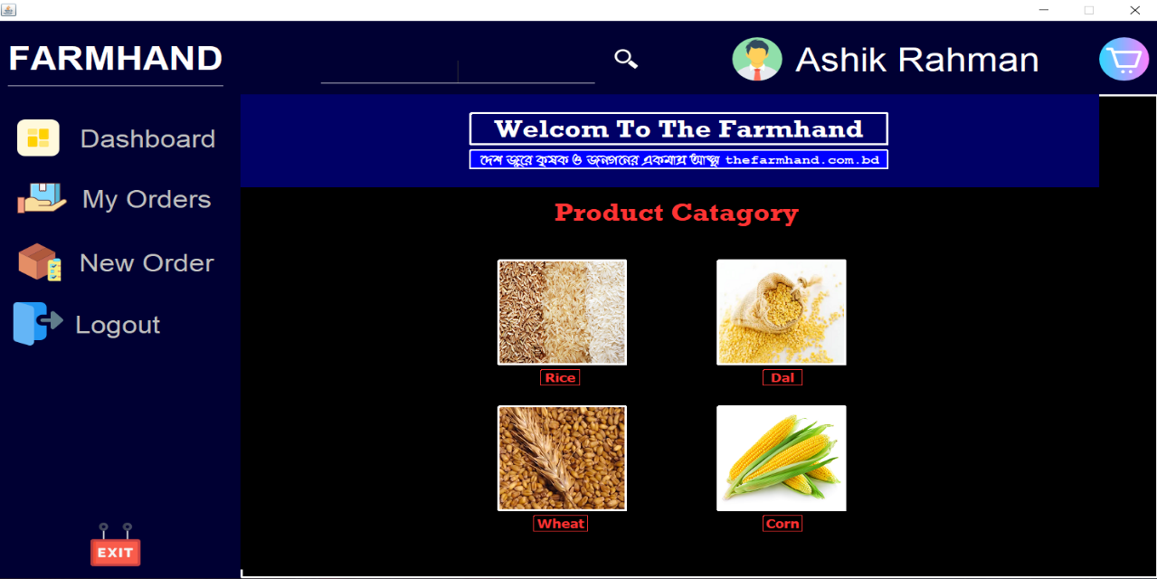

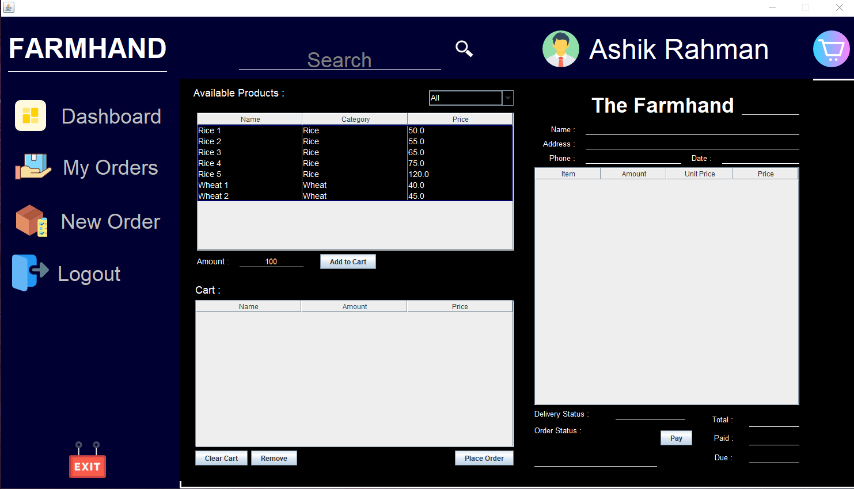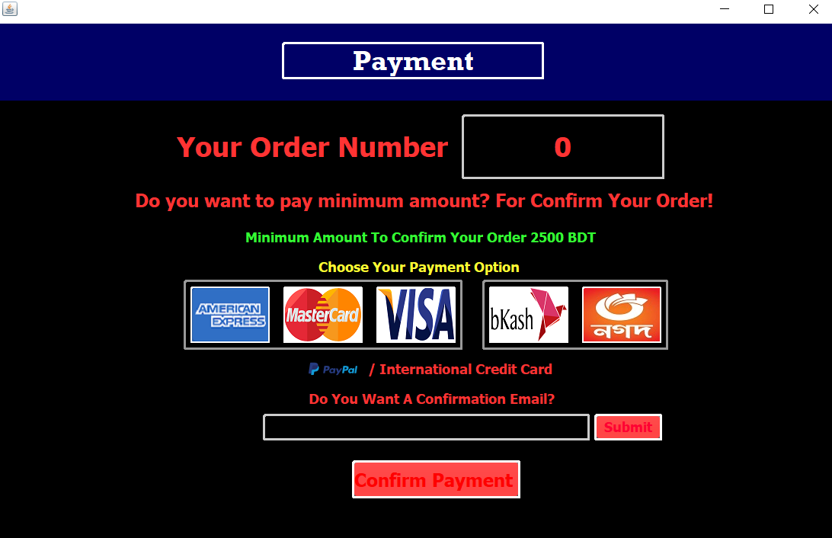

**Database Table Description:**

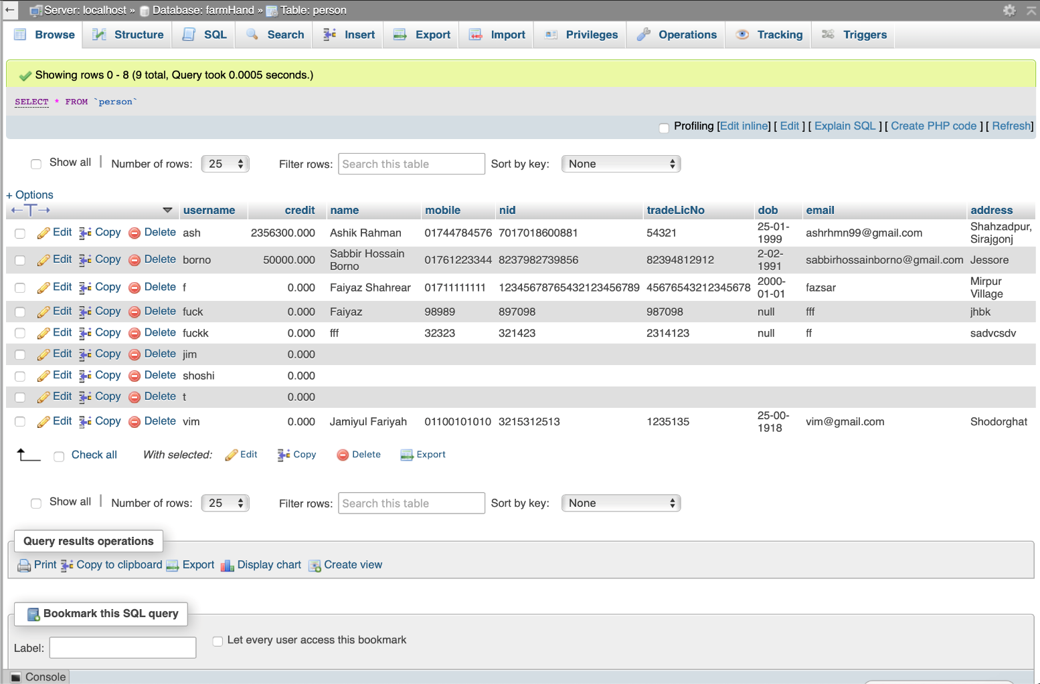

**Class Diagram:**

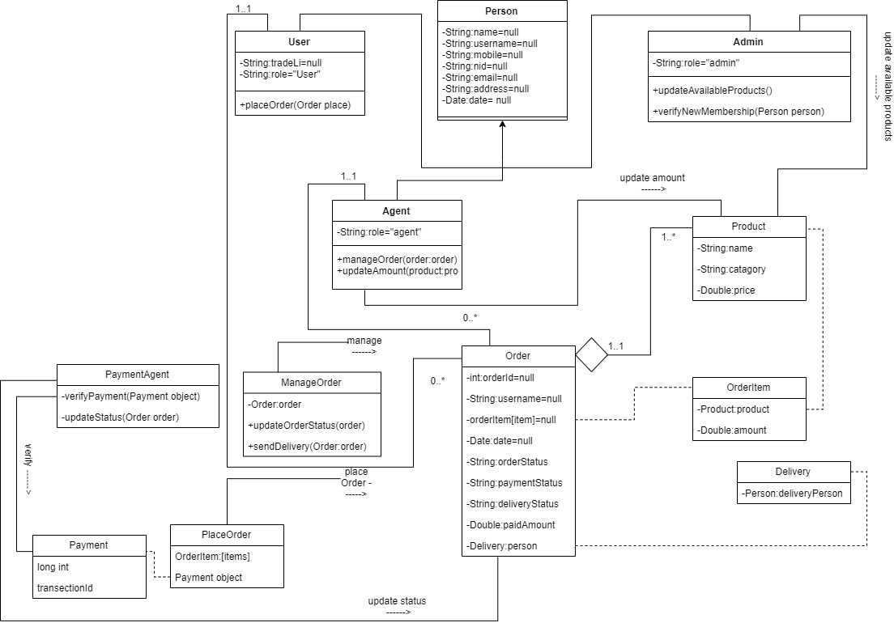

**Tools Used:**

To develop this project, we have used the following:

* NetBeans
* Xampp
* Draw.io
* MySQL
* PhpMyAdmin

**OOP and Java Concepts Used:**

* OOPs Concepts, Objects, Classes: The overall project is made by all OOP concepts.
* Static, final, this, super keywords: All keywords are used in the code.
* Packages: Used to organize the code files.
* Exception Handling: Used to handle all exceptions.
* JDBC (Java Database Connectivity): Used to connect the database with the source code.

**Impact of this Project:**

Now at the present situation farmers are getting 31 takas for per kg rice what will be 38 taka per kg rice if the system goes on real life. After Launch this software farmer and customer can be satisfied and farmer can get their proper value of crops. The company can give full loan process if it works on profit. Gradually it will add all grocery items to make the platform easier.at the starting point system will work on district wise but it’ll provide service to entire country. There will be a go-down process where we can store some product as future collection in case of any bad situation, we can provide customer their needs. Our mission with this project is to provide our services to whole Bangladesh. We hope that if it works according to our mission, one day it will be able to balance the social inequality. We can solve unemployment problem by adding employment on this project. We believe “coming together is a beginning. Keeping together is progress. Working together is success.”

**Limitations and Possible Future Improvements:**

* Provide loan to the farmers.
* Add all grocery items gradually.
* Provide service to entire country.
* Export product to foreign countries if the project goes that far.